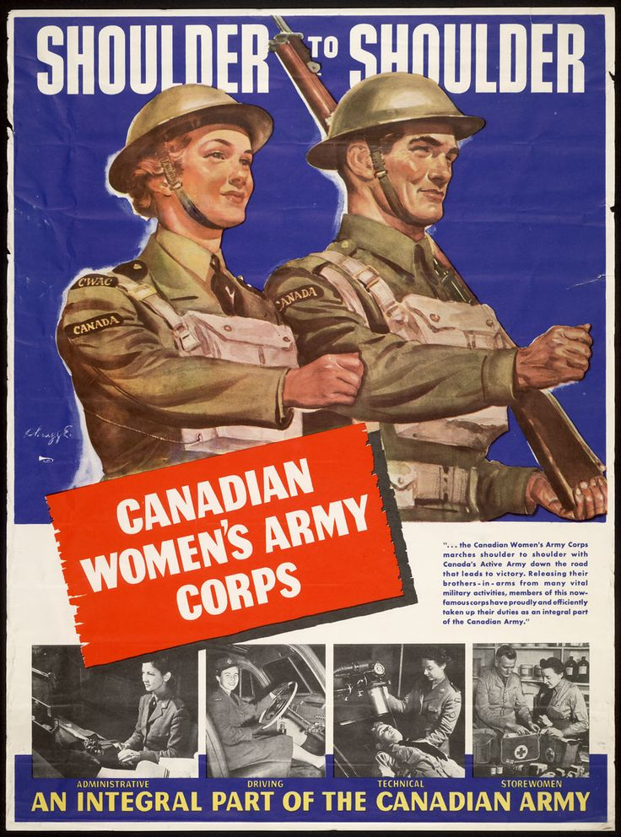
- Picture: The picture here depicts a man and woman In the army during WW2. Largely showing off the positions woman can have to help and saying they're a big part of the army because of how important the positions are. The corps is known as the CWAC(Canadian Woman's Army Corps).

- Technique: Something I noticed at first was the amount of colour in the picture because many times its just one colour not three. They also used more pictures to show off what it's you do thus making it more desirable or wanted. A bit part is putting the woman next to the man when at the time wasn’t popular.

- Effective? Personally, I still think it would be effective because its like a lot of posters today for the military but now they have more choices when it comes to the military. And it just shows a little glimpse of stuff you can do so clearly there are more options.

