Poems and Lyrics
How to analyse a poem/song:
- Listen or read without distractions and note the tone and mood.
- Annotate for words, devices, and structure.
- What is your opinion of the main idea/message AND one quote/lyric that supports that theme/concept?
- Do research on what others think: Read a review, analysis, author and date of publication or watch a video/interview.
- Add notes on what you learned and prepare to potentially expand in a complete analysis!
Notes from class on why we read poetry and listen to music:
Why do we listen/read music and poetry?
-
-
-
-
-
-
-
-
-
-
What does poetry mean to me???
-
-
-
-
-
-
-
-
-
-
-

Reading: Follow the process for the analysing poems and songs and practice as a
class, in small groups and/or your own to explain in complete paragraphs what they mean to YOU? Be sure to justify your rational with evidence from the text. (devices, words, lyrics/quotes)
Writing: Use the poems as models to write your own versions of the poems.

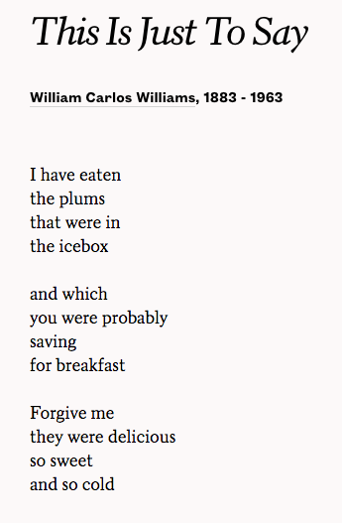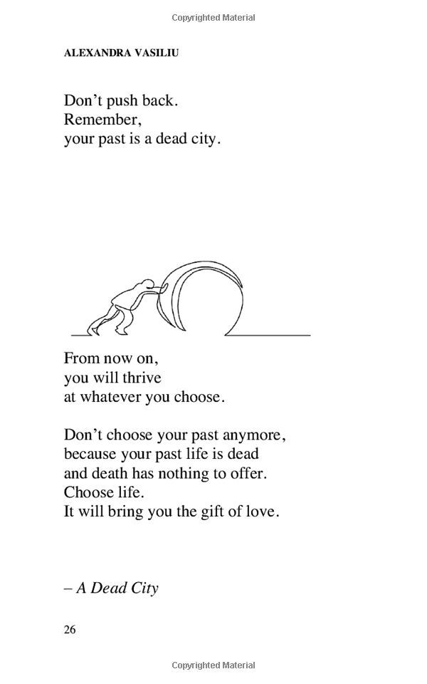

Thanksgiving
by Anonymous
A mountain of baby carrots,
a turkey the size of a cow.
a river full of gravy
a dog that says meow
Every pie known to man
and gallons full of ice cream.
By the time my dinner is over
I surely won’t be lean.

The Warrior

Some kids have dads who raise them to be golfers. Others, quarterbacks. Still others to play tennis or soccer or baseball. I was raised to cage ﬁght. Ever since I was three, my dad schooled me to brawl. Taught me to grapple, box,ground-and-pound, strike while standing up, and submitting opponent while lying down. From Sambo to Brazilianjiu-jitsu, Greco-Roman wrestling to Aikido, joint locks to pin holds to pressure-point manipulation, I’m an assassin in the art of hurt. My father wants me to do more than just defeat my opponents; he wants me to destroy.

Mr. N’s modelled example:

Mange Mange are words that will forever remind me of growing up at NoNa’s house. Strait sugar out of the bowl. Fifty-two questions of what I want to eat next. The sting of the back of NoNo’s hand on my cheek. I used you scream, “Stop talking like that to me!” They taught me the importance of family and that food brings people together and should be celebrated. From picking carrots and tomatoes in the garden to sleeping on the carpet floor, I’m the first and favorite and always will be. Three kisses on the cheek is the standard; dreams that my children will one day meet her and see the seas of colors, a crumbling home on a mountainside that made raindrops gather in my eyes.

Personal Example: (Just rough copy it out!)

Use this template to practice how devices effect imagery and your understanding:
Lyric or Line | Device | Explanation

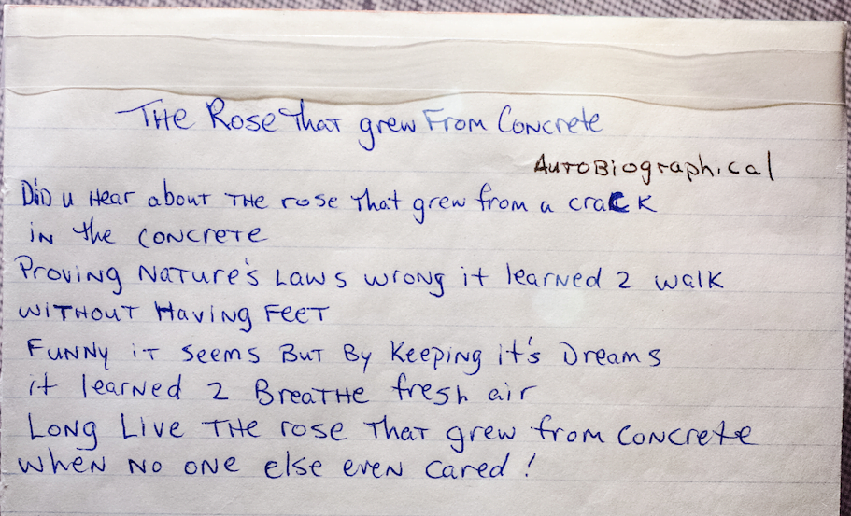

Mother to Son
BY LANGSTON HUGHES
Well, son, I’ll tell you:
Life for me ain’t been no crystal stair.
It’s had tacks in it,
And splinters,
And boards torn up,
And places with no carpet on the floor—
Bare.
But all the time
I’se been a-climbin’ on,
And reachin’ landin’s,
And turnin’ corners,
And sometimes goin’ in the dark
Where there ain’t been no light.
So boy, don’t you turn back.
Don’t you set down on the steps
’Cause you finds it’s kinder hard.
Don’t you fall now—
For I’se still goin’, honey,
I’se still climbin’,
And life for me ain’t been no crystal stair.
Tattoo
What once was meant to be a statement—
a dripping dagger held in the fist
of a shuddering heart—is now just a bruise
on a bony old shoulder, the spot
where vanity once punched him hard
and the ache lingered on. He looks like
someone you had to reckon with,
strong as a stallion, fast and ornery,
but on this chilly morning, as he walks
between the tables at a yard sale
with the sleeves of his tight black T-shirt
rolled up to show us who he was,
he is only another old man, picking up
broken tools and putting them back,
his heart gone soft and blue with stories.
from Delights & Shadows, Copper Canyon Press, Port Townsend, WA 200

I Wandered Lonely as a Cloud
William Wordsworth

I wandered lonely as a cloud
That floats on high o'er vales and hills,
When all at once I saw a crowd,
A host, of golden daffodils;
Beside the lake, beneath the trees,
Fluttering and dancing in the breeze.

Continuous as the stars that shine
And twinkle on the milky way,
They stretched in never-ending line
Along the margin of a bay:
Ten thousand saw I at a glance,
Tossing their heads in sprightly dance.

The waves beside them danced; but they
Out-did the sparkling waves in glee:
A poet could not but be gay,
In such a jocund company:
I gazed—and gazed—but little thought
What wealth the show to me had brought:

For oft, when on my couch I lie
In vacant or in pensive mood,
They flash upon that inward eye
Which is the bliss of solitude;
And then my heart with pleasure fills,
And dances with the daffodils.

Pink Floyd - Another Brick In The Wall
We don't need no education
We dont need no thought control
No dark sarcasm in the classroom
Teachers leave them kids alone
Hey! Teachers! Leave them kids alone!
All in all it's just another brick in the wall.
All in all you're just another brick in the wall.
We don't need no education
We dont need no thought control
No dark sarcasm in the classroom
Teachers leave them kids alone
Hey! Teachers! Leave us kids alone!
All in all it's just another brick in the wall.
All in all you're just another brick in the wall.
[8:20] "Wrong, Do it again!"
"If you don't eat yer meat, you can't have any pudding. How can you
have any pudding if you don't eat yer meat?"
"You! Yes, you behind the bikesheds, stand still laddy!"
{9:00} [Sound of many TV's coming on, all on different channels]
"The Bulls are already out there"
Pink: "Aaaaaaaaaaaaaaaaaaaaaaaarrrrrgh!"
"This Roman Meal bakery thought you'd like to know."
I don't need no arms around me
And I don’t need no drugs to calm me.
I have seen the writing on the wall.
Don't think I need anything at all.
No! Don't think I'll need anything at all.
All in all it was all just bricks in the wall.
All in all you were all just bricks in the wall.
[10:50] Goodbye, cruel world
I'm leaving you today
Goodbye, goodbye, goodbye
Goodbye, all you people
There's nothing you can say..

"Through The Wire" by K. West
Through the fire, to the limit, to the wall
For a chance to be with you, I'd gladly risk it all
Through the fire, through whatever, come what may
For a chance at loving you, I'd take it all the way
Right down to the wire, even through the fire
I drink a Boost for breakfast, an Ensure for dessert
Somebody ordered pancakes, I just sip the sizzurp
That right there could drive a sane man berserk
Not to worry, Mr. H-to-the-Izzo's back to wizzerk
How do you console my mom or give her light support
Tellin' her her son's on life support?
And just imagine how my girl feel
On the plane scared as hell that her guy look like Emmett Till
She was with me before the deal, she'd been tryna be mine
She a Delta, so she'd been throwin' that Dynasty sign
No use in me tryna be lyin', I been tryna be signed
Tryin' to be a millionaire, how I used two lifelines
In the same hospital where Biggie Smalls died
The doctor said I had blood clots, but I ain't Jamaican, man
Story on MTV and I ain't tryna make a band
I swear, this right here, history in the makin', man
[Chaka Khan:]
Through the fire, to the limit, to the wall
For a chance to be with you, I'd gladly risk it all
Through the fire, through whatever, come what may
For a chance at loving you, I'd take it all the way
Right down to the wire, even through the fire
I really apologize for everything right now
If it's unclear at all, man
They got my mouth wired shut
For like… I dunno, the doctor said like six weeks
Y'know, he had, I had reconstructive surgery on my jaw
I looked in the mirror
And half my jaw was in the back of my mouth, man
I couldn't believe it
But I'm still here for y'all right now, man
This what I got to say right here, dawg
Yeah, turn me up, yeah, uh
What if somebody from the Chi' that was ill got a deal
On the hottest rap label around?
But he wasn't talkin' 'bout coke and birds
It was more like spoken word, 'cept he's really puttin' it down?
And he explained the story 'bout how blacks came from glory
And what we need to do in the game
Good dude, bad night, right place, wrong time
In the blink of a eye, his whole life changed
If you could feel how my face felt
You would know how Mase felt (Mason Betha!)
Thank God I ain't too cool for the safe belt
I swear to God, driver two wanna sue
I got a lawyer for the case, to keep what's in my safe safe
My dawgs couldn't tell if I…
I looked like Tom Cruise in Vanilla Sky, it was televised
There's been an accident like GEICO
They thought I was burnt up like Pepsi did Michael
I must got a angel, 'cause look how death missed his ass
Unbreakable, what, you thought they'd call me Mr. Glass?
Look back on my life like the Ghost of Christmas Past
Toys "R" Us where I used to spend that Christmas cash
And I still won't grow up, I'm a grown-ass kid
Swear I should be locked up for stupid shit that I did
But I'm a champion, so I turned tragedy to triumph
Make music that's fire, spit my soul through the wire
[Chaka Khan:]
Through the fire, to the limit, to the wall
For a chance to be with you, I'd gladly risk it all
Through the fire, through whatever, come what may
For a chance at loving you, I'd take it all the way
Right down to the wire, even through the fire

Important Poetic/Literary Devices
*Write in a personal example that you will NEVER forget for each device.
- Alliteration. This is one of the easiest go-to devices to use. Alliteration involves the quick repetition of the first letters, and therefore the first sounds, of words.
  - The white witch wanted to write a new spell.
  - Phil Fought Ferociously
  - Ex.
- Personification. Giving inanimate objects and other phenomena human traits.
  - The leaves danced in the wind, twirling round and round before bowing out and resting on the cold ground.
  - Ex.
- Simile. Comparing two unrelated things to creating new understanding and meaning. They are marked by the use of "like," "as,"or "such as."
  - She ran like the wind.
  - Ex.
- Imagery: It is the use of figurative language to create visual representations of actions, objects and ideas in our mind in such a way that they appeal to our physical senses. For example:
- The room was dark and gloomy. -The words “dark” and “gloomy” are visual images.
- The river was roaring in the mountains. – The word “roaring” appeals to our sense of hearing.
- Ex.
- Ex.
- Cliché: Cliché refers to an expression that has been overused to the extent that it loses its original meaning or novelty. A cliché may also refer to actions and events which are predictable because of some previous events.
- in the nick of time – to happen just in time
- only time will tell – to become clear over time
- a matter of time – to happen sooner or later
- at the speed of light – to do something very quickly
- Ex.
- Ex.

- Symbolism. Using objects or action to mean something more than what appears on the surface.
  - The dawn of a new day often is used to symbolize a new beginning.
  - In daily life, people often associate colors with ideas. Black with death. Red with love. White with purity or peace.
  - Ex.
  - Ex.
- Metaphor. A device that asserts that one object is another, bringing new meaning to the original subject for a fresh understanding.
  - A common metaphor: it's raining cats and dogs.
  - She was a cheetah on the track today!
  - Ex.
- Hyperbole. Exaggerating a statement or idea to emphasize a point or emotion.
  - If I take another step, my feet will fall off.
  - I walked a million miles to school today.
  - Ex.
- Oxymoron. A device that puts two contradictory ideas together to create complex meaning.
  - Their relationship was an open secret.
  - You are a jumbo shrimp!
  - Ex.
- Irony: deliberately contrary to what one expects and is often amusing as a result.
Ex. A fire station burns down or “A death row pardon, two minutes too late…”
Ex.

- Repetition: The chorus of a song
Ex.

- ___________.

Ex.
Notes & brainstorming space:

