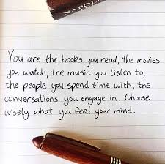Reflect on this quote by Jac Vanek. Is it true that you are made up of the things and people you surround yourself with? Do you always surround yourself with people and things that reflect the type of person you want to be?
For many of you these questions will also connect to the text you are reading. Feel free to draw on the experiences of the characters in your novel as well.

https://www.youtube.com/watch?v=5NHeFgaVWs8
Do you think this experiment is ethical? Why or why not?
Do you think this experiment had an impact? Can you change peoples’ minds so easily?
Monster: https://www.youtube.com/watch?v=jlqFm5R3QgM
The Wave: https://www.youtube.com/watch?v=1mcCLm_LwpE
ATDPTI: https://www.youtube.com/watch?v=NwiQb8OQ6dY (Alexie reads) *warning: some profanity and graphic lanugage
https://www.youtube.com/watch?v=ez23fpB7zVc (interview with Alexie)
Bite of the Mango: https://www.youtube.com/watch?v=rQOdt9ye4Wo
Internment:
The Marrow Thieves: https://www.youtube.com/playlist?list=PLVsLJC97bFPYcWpz--obmmuSchQxn7KcU
https://youtu.be/n746oUqBc_k

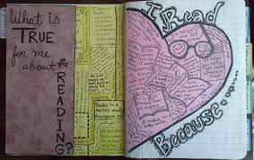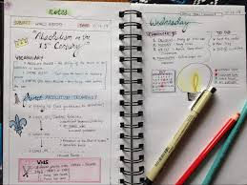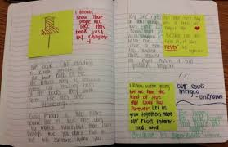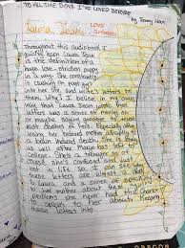
Lab Day Posting Guidelines
- Watch your video
- Write your post in word first and then copy paste to the forum
Your post should include:
- An intro (1-2 sentences) on what you watched
- How the video influenced your views on the novel/ issues in the novel
- At least 2 connections
  - Text to self
  - Text to text
  - Text to the world
Sample Video
*Remember that the video itself is considered a text so making connections from your novel to the film is a text to text connection
In the video “The blue eyes experiment” teacher Jane Elliott used a social experiment to teach her students about the inherent racism in our society. She seperated her students by the colour of their eyes and treated them differently based on this physical trait. Watching this video was challenging, seeing young children being treated poorly, simple because they were different from their peers was heartbreaking. It made me think more deeply about how children are treated around the world for the colour of their skin and how I was probably treated better as a child because I was white. I was also reminded of the scene in April Raintree when April speaks to her ability to “look white”, April was a kind of chameleon, she could pretend to be white when it served her, while Cheryl could not so easily change her stripes. Through this video, I feel I now have a better understanding of how April and Cheryl felt about their appearance and the way they were treated in the world. It also makes me more conscious of the experiences of those around me and the prejudices in our world.
Forbes Article:
https://www.forbes.com/sites/jeffschmitt/2013/07/16/10-keys-to-writing-a-speech/#17cdb174fb75
Watch:
https://motivationmentalist.com/2018/02/15/how-the-wisdom-of-a-third-grade-dropout-will-change-your-life/
Identify 3 elements of a “great speech” in Rick Rigsby’s speech “How the Wisdom of a Third Grade Dropout will Change Your Life”
Jim Carrey - Watch (at least) the first 2 min
https://www.youtube.com/watch?v=YAzTIOy0ID0
Jeff Daniels in The Newsroom - 1:30 to the end *features some profanity, option to skip
https://www.youtube.com/watch?v=VMqcLUqYqrs
Emma Gonzalez - Parkland Survivor March for our Lives Speech
There is a long silence from about the 2-6 min mark, this is a technique the speaker uses to drive home a point, make sure that you watch the last part to get the full impact of the speech...
https://www.youtube.com/watch?v=u46HzTGVQhg
Based on one of the overarching themes in your novel choose a topic that you would like to use for a speech.
Examples
Theme: Family → Speech Topic: The importance of strong family supports in a teens life
Theme: Identity → Speech Topic: The value of youth developing a strong sense of self
Theme: War/Survival → Speech Topic: What can we learn from stories of survival
Theme: Authority → Speech Topic: Parental discipline (funny approach)
Before writing any speech you need to figure out a few key points…
- WHO you are writing your speech for (the audience) and WHY

- WHAT your speech is going to be about (its topic)

- HOW long it needs to be eg. 3 minutes, 5 minutes...
Below is a list of great ways to open up a speech and grab your audience's attention:
- Joke
- Quote
- Statistic
- One liner
Do some research and come up with a hook for your speech
Below is a list of great ways to open up a speech and grab your audience's attention:
- Joke
- Quote
- Statistic
- One liner
Do some research and come up with a hook for your speech
Topic: The value of offering mental health services in all schools
Who (audience): Parents, Teachers and Administrators
Why (the purpose of the speech): Teens are struggling with mental health issues at an alarming rate. Offering mental health services in all schools would reduce barriers to youth and improve their overall health and school experience.
Hook: “3.2 million Canadian Youth, ages 12-19 are at risk of developing depression”
Explain your choices based on your audience: I chose this hook because I felt that a statistic highlighting the vast number of teens struggling with mental illness would hit home for teachers and parents.

