The Changing Face

A)

1. Choose one of the faces provided from the, “The Changing Face of America” article.
2. Write a “summarized” biographical description of your character. Consider the following guideline questions in an outline.  
   a) What is his or her name?  
   b) What country were they born in and where does their family originally come from?  
   c) What do they do for a “living” and what do their parents do?  
   d) What do they like to do for fun?  
   e) Are they happy? Why or why not? What types of struggles have they had to overcome?  
   f) Where will they be in ten years from now?
3. Type your rough copy and glue your picture to the top of the good copy. (as shown in class.) Or cut and paste it into your document. (from weebly)
4. Send your picture and bio to Mr. N’s email. ([pneuendorff@retsd.mb.ca](mailto:pneuendorff@retsd.mb.ca))

B) Find a video clip or picture that demonstrates a social experiment or common Gap that we have in society. If you were a news reporter and had 30 seconds to make a video posting about this visual in the media, what would you say and how would you deliver it?

C)

Walk about facial expression and handshake activity (Mr. N. will explain)

1. **The Viewing gallery**  
   -Look at all the other faces that your fellow classmates created identities for. Do you think the bio’s are believable? Why or Why not? Discuss and share as a class.
2. Write a journal entry that you are prepared to share with a group in the class, describing how you have been “judged” or wrongly accused or made to feel different in the past and tell us how it made you feel.

**The Changing Face of America**

* [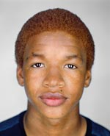](javascript:void(0);)
* [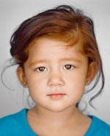](javascript:void(0);) [](javascript:void(0);)
* [](javascript:void(0);) [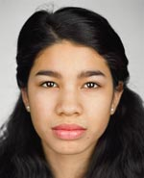](javascript:void(0);)
* [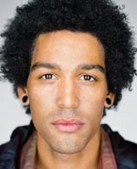](javascript:void(0);) [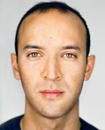](javascript:void(0);)
* [](javascript:void(0);) [](javascript:void(0);)
* [](javascript:void(0);) [](javascript:void(0);)
* [](javascript:void(0);) [](javascript:void(0);)
* [](javascript:void(0);) [](javascript:void(0);)
* [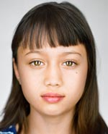](javascript:void(0);) [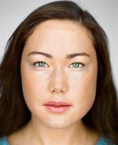](javascript:void(0);)
* [](javascript:void(0);) [](javascript:void(0);)
* [](javascript:void(0);) [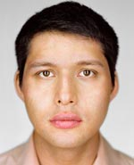](javascript:void(0);)
* [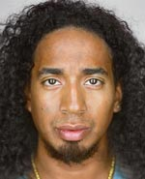](javascript:void(0);) [](javascript:void(0);)
* [](javascript:void(0);) 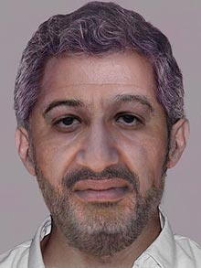
* [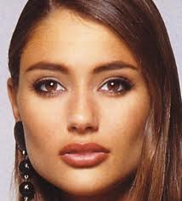](http://www.google.ca/url?sa=i&rct=j&q=&esrc=s&frm=1&source=images&cd=&cad=rja&docid=HPCzrb5lWoxKtM&tbnid=JiZiMn2Lokya0M:&ved=0CAUQjRw&url=http://www.womenlargejaw.com/square-jaw/native-american-face&ei=5C14UsK2CeivjALY1YDwDA&psig=AFQjCNF5lF0vsmnzcIJpOPgqcGXSWh8n9w&ust=1383694113755024)
* 