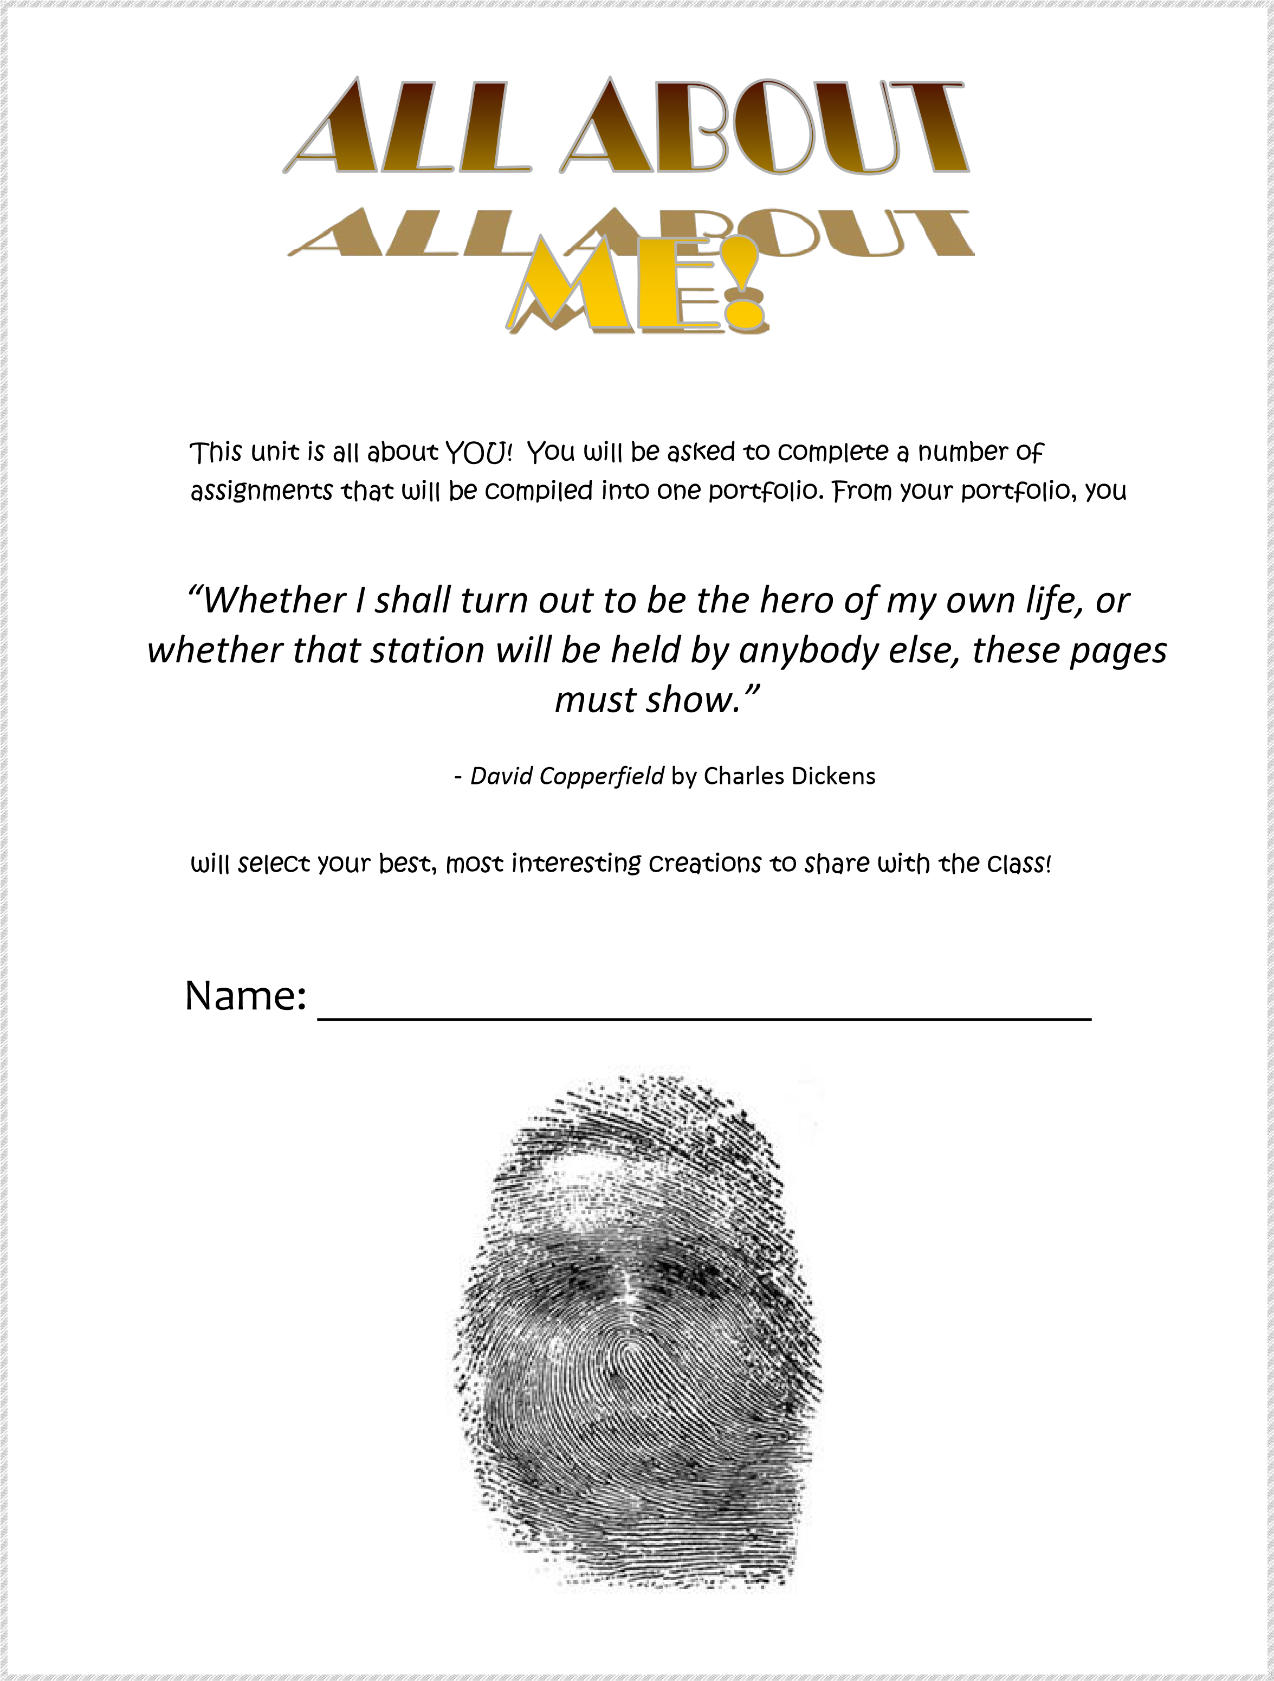
Part 1:
Introductory Writing Assignment: An Experience that Shapes/ed you and Empowers you to be proud of who you are!

Create a first person narrorative piece of writing, which conveys some important and interesting aspect of your identity and the best qualities of your talents as a writer. Plan your writing piece as if it would be published for a public audience. 25 marks (see writing rubric hand out)
Use Mr. Neuendorff’s “Memoirs of Uganda” example of which can be found at mrneuendorff.weebly.com You are to include:
- An outline and rough copy outline of your chosen form
- A description of your trip/vacation/family tradition/event…. And explain how it defines you and empowers you as an individual.
- Your piece should be 2 paragraphs long and include 2 pictures that represent or embody the experience you are describing. (Actual or representative)
- It should be typed and printed and/or sent to 365 assignments.

Use the writing process to outline, draft, revise, edit and proofread so that your final copy is your best work. Hand in all rough work and the outline with your final draft.
Your final draft will be assessed based on the following outcomes: I – O – M – L/S R/O
Focus (outcome 1: Explore thoughts, ideas feelings and experiences)
Support (outcome 4.1.1generate ideas)
Organization (outcome 4.1.3)
Mechanics (outcome 4.3.1-3spelling, grammar, punctuation)
Consider the following questions:
- Where did you go and why does this portray your identity?
- Who were with and does that have any significance?
- What did you do?
- What is the message about yourself that you are trying to convey to your audience?
- How does/has this event empowered you to be proud of your identity.

***Please be prepared to share your work with the class in some form.

Fill out the chart below and answer the question which accompanies it to explain your plan for your writing piece.
Writing Variables

Form:
Central Idea:
Purpose:
Public Audience:
Make a list of  5 sensory details you will consider using) | Touch, taste, smell, sight, sound.

Briefly describe why this event is important to you and why that would make other people interested to read it or listen to it. (5 marks)
_____________________________________________________________________________________
_____________________________________________________________________________________
_____________________________________________________________________________________ _____________________________________________________________________________________ _____________________________________________________________________________________
_____________________________________________________________________________________
_____________________________________________________________________________________
_____________________________________________________________________________________
_____________________________________________________________________________________

Part 2:

A. PERSONAL METAPHORS
A Metaphor is a figure of speech. It can be defined as follows:
A metaphor is when two things are compared by using one kind of object, or using one in place of another, to suggest the likeness between them. Metaphors do not use the words “like” or “as”
Rug Rat:
Rug rat = infant. An infant crawls on all fours and chews on everything it can. Often the child is on a carpeted floor to prevent injury. Babies are known for their constant drooling and uncleanliness, and their willingness to eat indiscriminately. Compare this description to our common perception of a rat. The rug rat is an effective metaphor because we visualize a cross between rat and baby - something that has an air of both sarcasm and truth, and may also reveal something sinister about how our culture perceives early childhood parenting.
"...neither shall ye defile yourselves with any manner of creeping thing that creepeth upon the earth." (Lev.11:44, referring to Kosher diet).
Couch Potato:
Couch potato = lazy person. A lazy person buries themselves in the cushions of a couch (sofa, chesterfield, La-Z-Boy) in safe, sedentary comfort, "vegging out" mindlessly in front of the TV, eyes in a fixed, submissive stare. A couch potato never leaves the home, and cannot be motivated, having everything nearby so they never have to move. Compare this to the potato, which is buried in the comfort and providence of soil and to which the only escape from its lifestyle is death. Covered in eyes, but without a brain or muscle, the potato is snuggled and unmotivated.
A comfortable sofa is fertile soil for the couch potato.
Road Hog:
Road hog = territorially aggressive driver. The territorially aggressive driver takes up far more space than they need. They tend to push aside other drivers in their efforts for territory and destination and in doing so, are impolite - even outright greedy, and are deemed unintelligent. This matches our concept of the hog, with our many phrases like "greedy as a pig", "you're making a pig of yourself" or "corporate pigs". One can visualize the pig at the feeding trough with other pigs, grunting and shoving with their self-centered intentions.
Passive drivers fatten the road hog.

Make a list of metaphorical comparisons. Think, “If I were an animal, what kind of animal would I be?” For each item, write the general LABEL and then your specific comparison. Be realistic, be somewhat honest, and be able to explain your choices. Don’t say you are a rose, if you’re really a weed!
Category | Label/type | Reasoning (point form)
1. Animal
2. Vehicle
3. Article of clothing
4. Day of the week
5. Food
6. Colour
7. Plant
8. Musical instrument
9. Geometric shape
10. Piece of furniture
11. Song
12. Season of the year
13. Television/Cart oon/Comic character
14. Natural
phenomenon
15. Word

Writing Assignment:
EXTENDED METAPHORS
Review your list of personal metaphors. Choose ONE that you can extend by explaining the comparison in detail. Write a paragraph by giving at least three reasons for your choice. For example, if you are like an alley cat, discuss at least three of the characteristics of an alley cat and explain the ways in which you have the same characteristics.
Now read the sample paragraph on the following page.

Artie Miller Miller 1
Mrs. Palmer
ELA 20F
12 February 2007
I am an Octagon!
An octagon is a geometric shape similar to a circle, but rather than smooth, round edges, it
has eight flat sides, that meet at an angle of 134 degrees. Out of many geometric shapes, I feel I am most like an octagon. First, an octagon is complex. Second, stop signs are often associated with the shape. Third, octagons can be categorized as ‘regular’ and ‘irregular.’ To conclude, an octagon is an appropriate metaphor for how I see myself because of its shared characteristics to both squares and circles, its association to stop signs, and the fact that it can be either regular, or irregular.

How effectively does this student explain why he feels he is like an octagon? Use the rubric below to evaluate his ideas.
Ideas  (1.1.1)  ________ | 5 | Thorough / perceptive explanation of how the object is a metaphor for student.
 | 4 | Specific explanation of how the object is a metaphor for student.
 | 3 | A general explanation of how the object is a metaphor for student.
 | 2 | A limited explanation of how the object is a metaphor for student.
 | 1 | Lacks sufficient explanation of how the object is a metaphor for student.
Organization  (4.1.3)  ________ | 5 | Paragraph flows and ideas are arranged in a purposeful order; transitions are purposeful and varied.
 | 4 | Paragraph flows and ideas are arranged in a logical order; transitions are varied.
 | 3 | Paragraph ideas are arranged in a functional order; the flow of paragraph slightly hindered; transitions are mechanical.
 | 2 | Lack of organization has resulted in poor flow of paragraph; transitions are unvaried and/or repetitious
 | 1 | Weak organization, which greatly impedes communication; transitions are missing or rarely used.

I am an Octagon!
An octagon is a geometric shape similar to a circle, but rather than smooth, round edges, it has eight flat sides, that meet at an angle of 134 degrees. Out of many geometric shapes, I feel I am most like an octagon. First, an octagon is complex for the reason that it bears characteristics similar to both squares and circles. I feel that this describes me because I am complex. At times I can be very easy-going and complacent, while at other times I can be very difficult and opinionated. Second, stop signs are often associated with the shape and I feel that this also represents me. Stop signs may be viewed as a symbol of safety; they signal to drivers to stop and look before they continue on their route. This is something that I often do in life when I am required to make important decisions. Third, octagons can be categorized as ‘regular’ and ‘irregular.’ This is similar to how I see myself; sometimes I feel as though I fit in with the people around me, but other times I feel ‘irregular,’ like I do not quite fit in. To conclude, an octagon is an appropriate metaphor for how I see myself because of its shared characteristics to both squares and circles, its association to stop signs, and the fact that it can be either regular, or irregular.
Now review the rubric on the previous page. How would this paragraph score in comparison to the first? What is different?

OUTLINING YOUR PARAGRAPH
Select which personal metaphor you will extend in your paragraph. Use the outline below to assist you in organizing your thoughts into a clear and effective paragraph. Be sure to use at least three supporting Now use the outline below to help you organize your ideas into a cohesive, well-organized paragraph. You will then submit a final typed draft with your outline.

Title _________________________________________________________

Thesis (Introduce the topic)
_______________________________________________________________________ _______________________________________________________________________ _______________________________________________________________________
Topic Sentence 1: First Supporting Detail (Begin with a transition word)
_______________________________________________________________________ _______________________________________________________________________
_______________________________________________________________________
Explanation/Development/Evidence of First Supporting Detail
_______________________________________________________________________
_______________________________________________________________________ _______________________________________________________________________
Topic Sentence 2: Second Supporting Detail (Begin with a transition word)
_______________________________________________________________________ _______________________________________________________________________
_______________________________________________________________________
Explanation/Development/Evidence of Second Detail
_______________________________________________________________________ _______________________________________________________________________ _______________________________________________________________________
Topic Sentence 3: Third Supporting Detail (Begin with a transition word)
_______________________________________________________________________ _______________________________________________________________________ _______________________________________________________________________

Explanation/Development/Evidence of Third Supporting Detail
_______________________________________________________________________
_______________________________________________________________________

Concluding Sentence
______________________________________________________________
______________________________________________________________
_______________________________________________________________________

Transitions: First, Second, Third, Similarly, Next, Before, After, The most important, For example, On one hand, Another example, Further, Consequently, Also, In the same way, As well

Concluding Transitions: In summary, To conclude, It may be seen, As a result, In short, Therefore, In conclusion, Thus, In brief

Extended Metaphor Rubric
Ideas  1.1.1  ________  5 | 5 | Thorough / perceptive explanation of how the object is a metaphor for student.
 | 4 | Specific explanation of how the object is a metaphor for student.
 | 3 | A general explanation of how the object is a metaphor for student.
 | 2 | A limited explanation of how the object is a metaphor for student.
 | 1 | Lacks sufficient explanation of how the object is a metaphor for student.
Organization  4.1.3  ________  5 | 5 | Paragraph flows and ideas are arranged in a purposeful order; transitions are purposeful and varied.
 | 4 | Paragraph flows and ideas are arranged in a logical order; transitions are varied.
 | 3 | Paragraph ideas are arranged in a functional order; the flow of paragraph slightly hindered; transitions are mechanical.
 | 2 | Lack of organization has resulted in poor flow of paragraph; transitions are unvaried and/or repetitious
 | 1 | Weak organization, which greatly impedes communication; transitions are missing or rarely used.
Language  Use &  Arrangement 4.2.3,4.2.4 ________  5 | 5 | Paragraph demonstrates precise vocabulary; sentence structures are varied and fluent.
 | 4 | Paragraph demonstrates varied and specific vocabulary; sentence structures are varied and clear.
 | 3 | Paragraph demonstrates conventional vocabulary but appropriate diction; sentences structures are somewhat varied and clear.
 | 2 | Paragraph demonstrates generalized, repetitious or inappropriate diction; sentence structures are simple and unvaried.
 | 1 | Paragraph demonstrates very limited diction; sentence structures are flawed.
Spelling and  Grammar  4.3  ________  5 | 5 | Virtually no grammar or spelling errors.
 | 4 | Some spelling and/or grammar errors. Communication is not hindered.
 | 3 | Several of spelling and/or grammar errors, which to some extent hinder communication.
 | 2 | Many spelling and/or grammar errors, which hinder communication.
 | 1 | Numerous spelling and/or grammar errors. Communication is severely hindered.

Part 3

Part 4: Bio-Poem/Where I`m From
Read the following poem with your classmates.
As we discuss the meaning behind each stanza, make notes on the poem.

Where I'm From
I am from clothespins, from Clorox and carbon-tetrachloride. I am from the dirt under the back porch.
(Black, glistening, it tasted like beets.) I am from the forsythia bush the Dutch elm whose long-gone limbs I remember as if they were my own.
I'm from fudge and eyeglasses, from Imogene and Alafair. I'm from the know-it-alls and the pass-it-ons, from Perk up! and Pipe down! I'm from He restoreth my soul with a cottonball lamb and ten verses I can say myself.
I'm from Artemus and Billie's Branch, fried corn and strong coffee. From the finger my grandfather lost to the auger, the eye my father shut to keep his sight.
Under my bed was a dress box spilling old pictures, a sift of lost faces to drift beneath my dreams. I am from those moments-- snapped before I budded -- leaf-fall from the family tree.

Write down your thoughts in response to the following prompts...
Where are you from? _____________________________________________ What are some geographic features/objects that you can find there?

What are some objects that remind you of your childhood?

Are there any smells or odours you associate with your childhood?

Are there any textures that remind you of your childhood?

Complete the chart found below...
Significant people in your life &  relationship to you. | Physical Traits | Character Traits | What do they mean to you? How have they influenced you?

